Expression from the K – Map
D = A’B’Bin + A’BB’in + AB’B’in+ ABBin
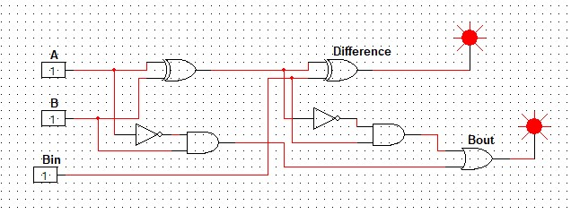
Bout = A’Bin + A’B + BBin

Logical diagram :-

